Cell discovery brings blood disorder cure closer

August 13, 2014

Monash University

A cure for a range of blood disorders and immune diseases is in sight, according to scientists who have unraveled the mystery of stem cell generation. Found in the bone marrow and in umbilical cord blood, HSCs are critically important because they can replenish the body's supply of blood cells. Leukemia patients have been successfully treated using HSC transplants, but medical experts believe blood stem cells have the potential to be used more widely.

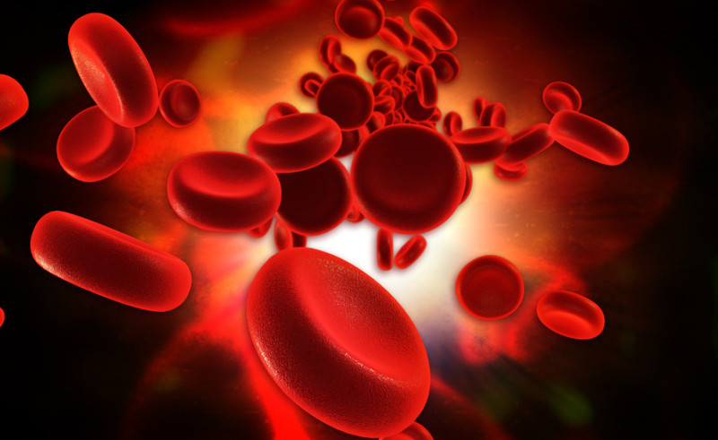
Blood cells (stock illustration). "HSCs are one of the best therapeutic tools at our disposal because they can make any blood cell in the body. Potentially we could use these cells in many more ways than current transplantation strategies to treat serious blood disorders and diseases, but only if we can figure out how they are generated in the first place. Our study brings this possibility a step closer," one researcher said.
Credit: © abhijith3747 / Fotolia
[Click to enlarge image]
A cure for a range of blood disorders and immune diseases is in sight, according to scientists who have unravelled the mystery of stem cell generation.
The Australian study, led by researchers at the Australian Regenerative Medicine Institute (ARMI) at Monash University and the Garvan Institute of Medical Research, is published today in Nature. It identifies for the first time mechanisms in the body that trigger hematopoietic stem cell (HSC) production.
Found in the bone marrow and in umbilical cord blood, HSCs are critically important because they can replenish the body's supply of blood cells. Leukemia patients have been successfully treated using HSC transplants, but medical experts believe blood stem cells have the potential to be used more widely.
Lead researcher Professor Peter Currie, from ARMI explained that understanding how HSCs self-renew to replenish blood cells is a "Holy Grail" of stem cell biology.
"HSCs are one of the best therapeutic tools at our disposal because they can make any blood cell in the body. Potentially we could use these cells in many more ways than current transplantation strategies to treat serious blood disorders and diseases, but only if we can figure out how they are generated in the first place. Our study brings this possibility a step closer," he said.
A key stumbling block to using HSCs more widely has been an inability to produce them in the laboratory setting. The reason for this, suggested from previous research, is that a molecular 'switch' may also be necessary for HSC formation, though the mechanism responsible has remained a mystery, until now.
In this latest study, ARMI researchers observed cells in the developing zebra fish -- a tropical freshwater fish known for its regenerative abilities and optically clear embryos -- to gather new information on the signalling process responsible for HSC generation.
Using high-resolution microscopy researchers made a film of how these stem cells form inside the embryo, which captured the process of their formation in dramatic detail.
Professor Currie said when playing back these films they noticed that HSCs require a "buddy" cell type to help them form. These "buddies," known as endotome cells, have stem cell inducing properties,
"Endotome cells act like a comfy sofa for pre HSCs to snuggle into, helping them progress to become fully fledged stem cells. Not only did we identify some of the cells and signals required for HSC formation, we also pinpointed the genes required for endotome formation in the first place," Professor Currie said.
"The really exciting thing about these results is that if we can find the signals present in the endotome cells responsible for embryonic HSC formation then we can use them in vitro to make different blood cells on demand for all sorts of blood related disorder."
"Potentially it's imaginable that you could even correct genetic defects in cells and then transplant them back into the body," Professor Currie said.
Dr Georgina Hollway, from the Garvan Institute of Medical Research said the work highlights how molecular processes in the body play a key role in HSC formation.
"We now know that these migratory cells are essential in the formation of hematopoietic stem cells, and we have described some of the molecular processes involved. This information is not the whole solution to creating them in the lab, but it will certainly help." said Dr Hollway.

